PhD Training
The Sida Mathematics project at University of Dar es Salaam under competitive bases won a proposal among the 12 proposals funded by Sida Bilateral programmes of Sweden. The overall goal of this project is to build capacity for graduate training and research in mathematics at the University of Dar es Salaam (UDSM) through collaboration with Swedish universities. The Sida Bilateral programme sponsorship at UDSM was a five years from July 2015 – June 2020 and has been given extension of one year until June 2021.
This project sponsored three staffs from UDSM for PhD training on sandwich mode enrolled in Sweden from 2016. The three PhD students sponsored by this project are:
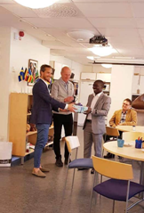
Name: Edward Ngailo
Institution: Linköping University
PhD Title: On the product of inverse covariance
matrices and normal vectors with applications to
Discriminant analysis and Portfoliotheory
Current status: Edward Ngailo defended viva at Linköping University
in 8th June 2020.
Email: Edward Ngailoedongailo9@gmail.com
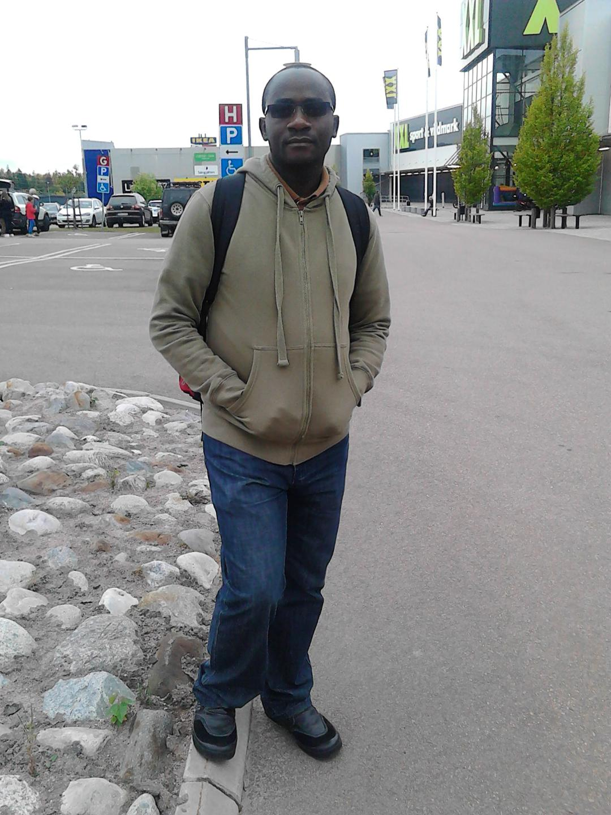
Name: Pitos Seleka Biganda
Institution: Mälardalen University

PhD Title: PageRank algorithms, Markov
chains and matrix analysis for changing
networks and analysis of big data

Current status: Mr. Pitos expecting to defend viva in
November 2020.

Email: pitosel@yahoo.com

Name: Uledi Ayubu Ngulo
Institution: Linköping University

PhD Title: An Investigation of decomposition
Methodsfor solving large-scale Multi-level
Optimization models.

Current status: Mr. Pitos expecting to complete
studies in June 2021.

